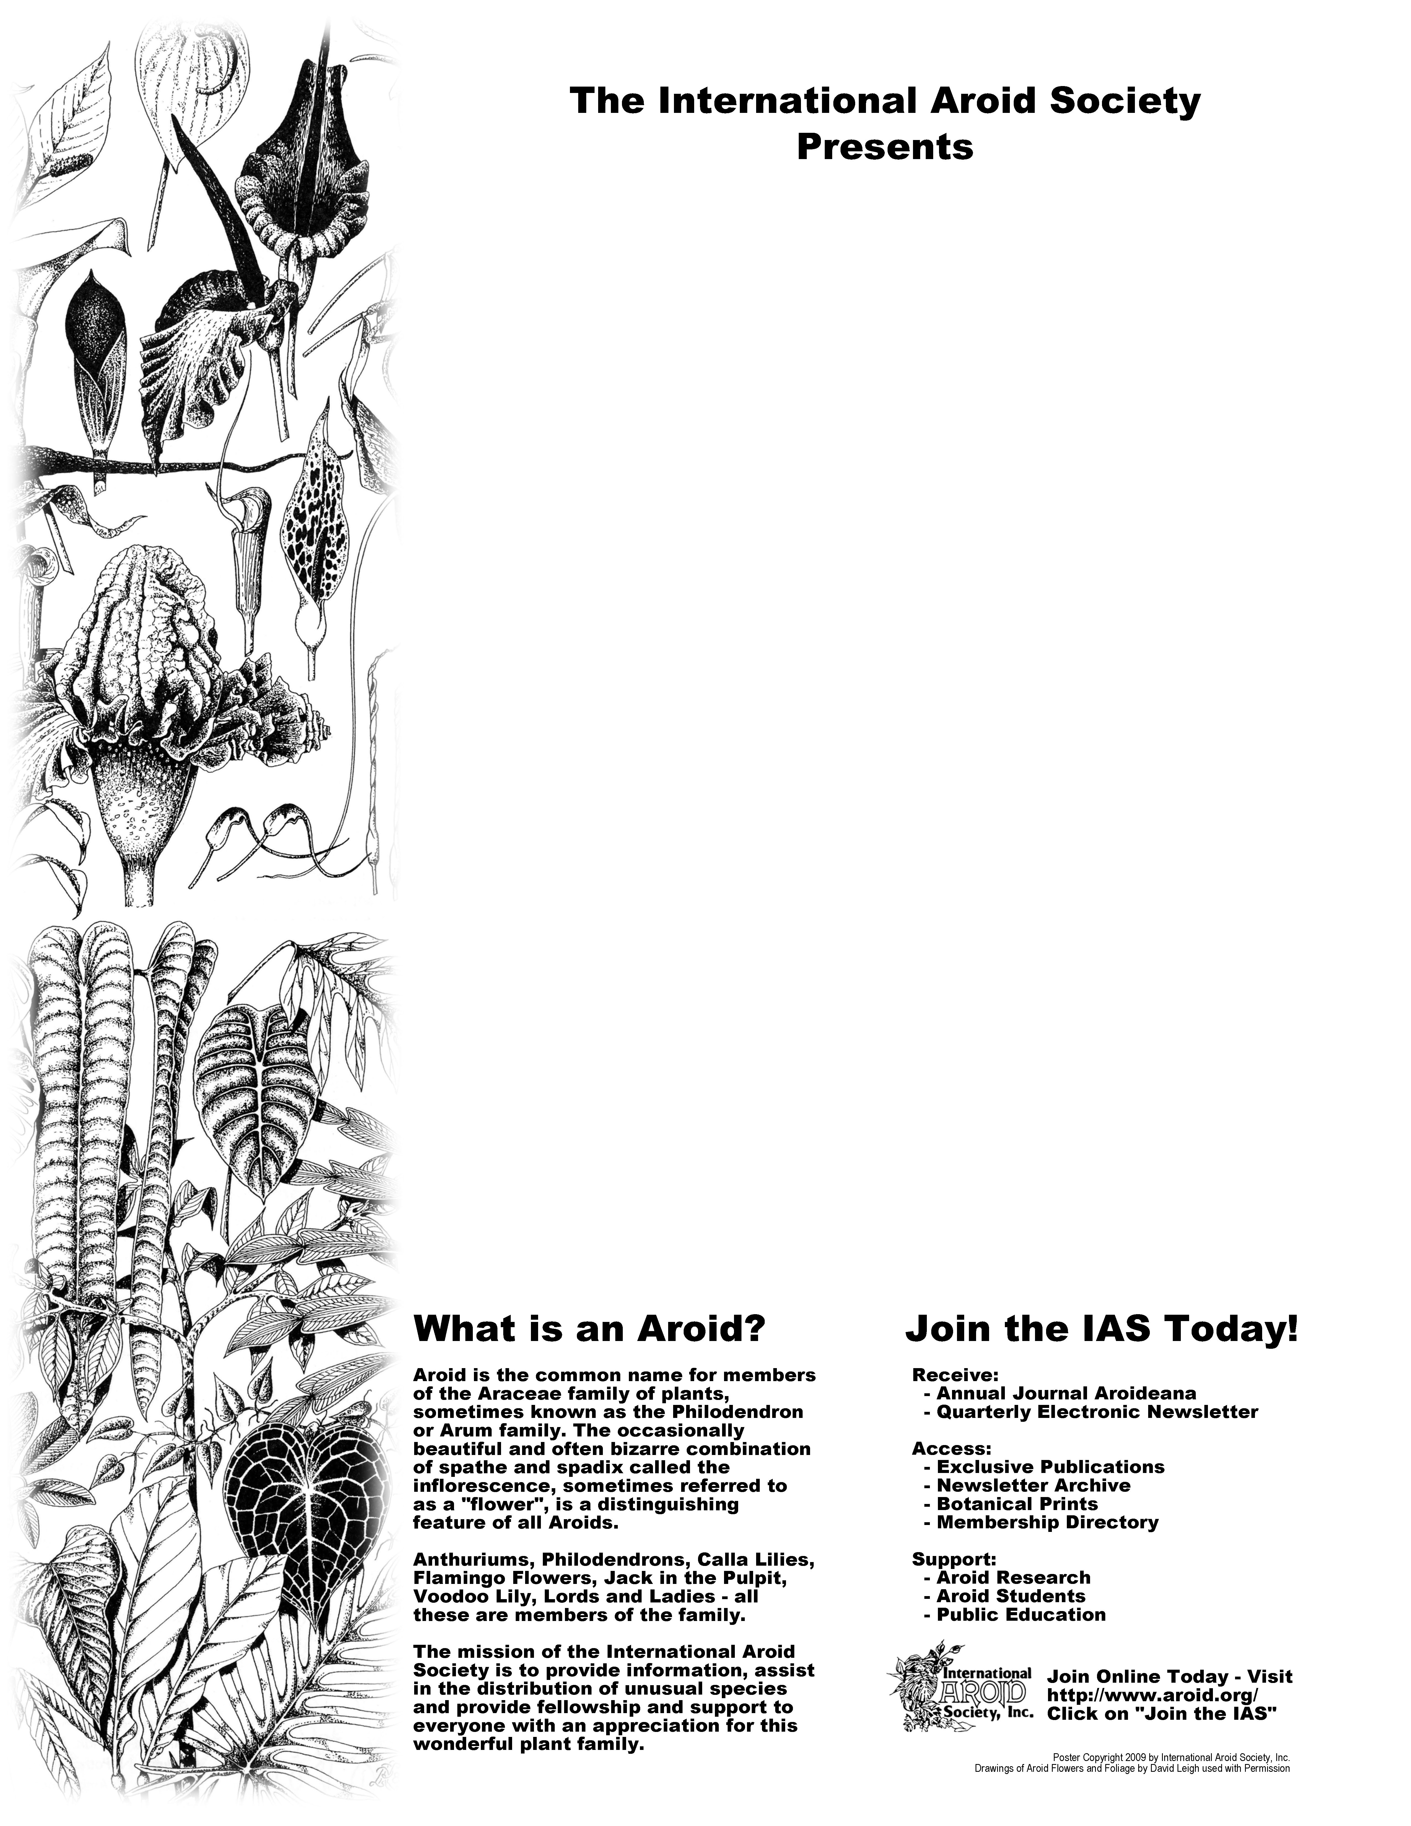
32nd Annual
AROID
SHOW AND SALE

September 19th & 20th, 2009
9:30AM – 4:30PM Both Days
Fairchild Tropical Garden*
Miami, Florida, USA

- Rare Plants
- Stunning Displays
- International Vendors
- Saturday Talks

For more information, visit http://www.aroid.org/
Or call Tricia Frank at 305-665-4369

* Show is free with paid garden admission
Visit http://www.aroid.org/show for link to a $5 discount

