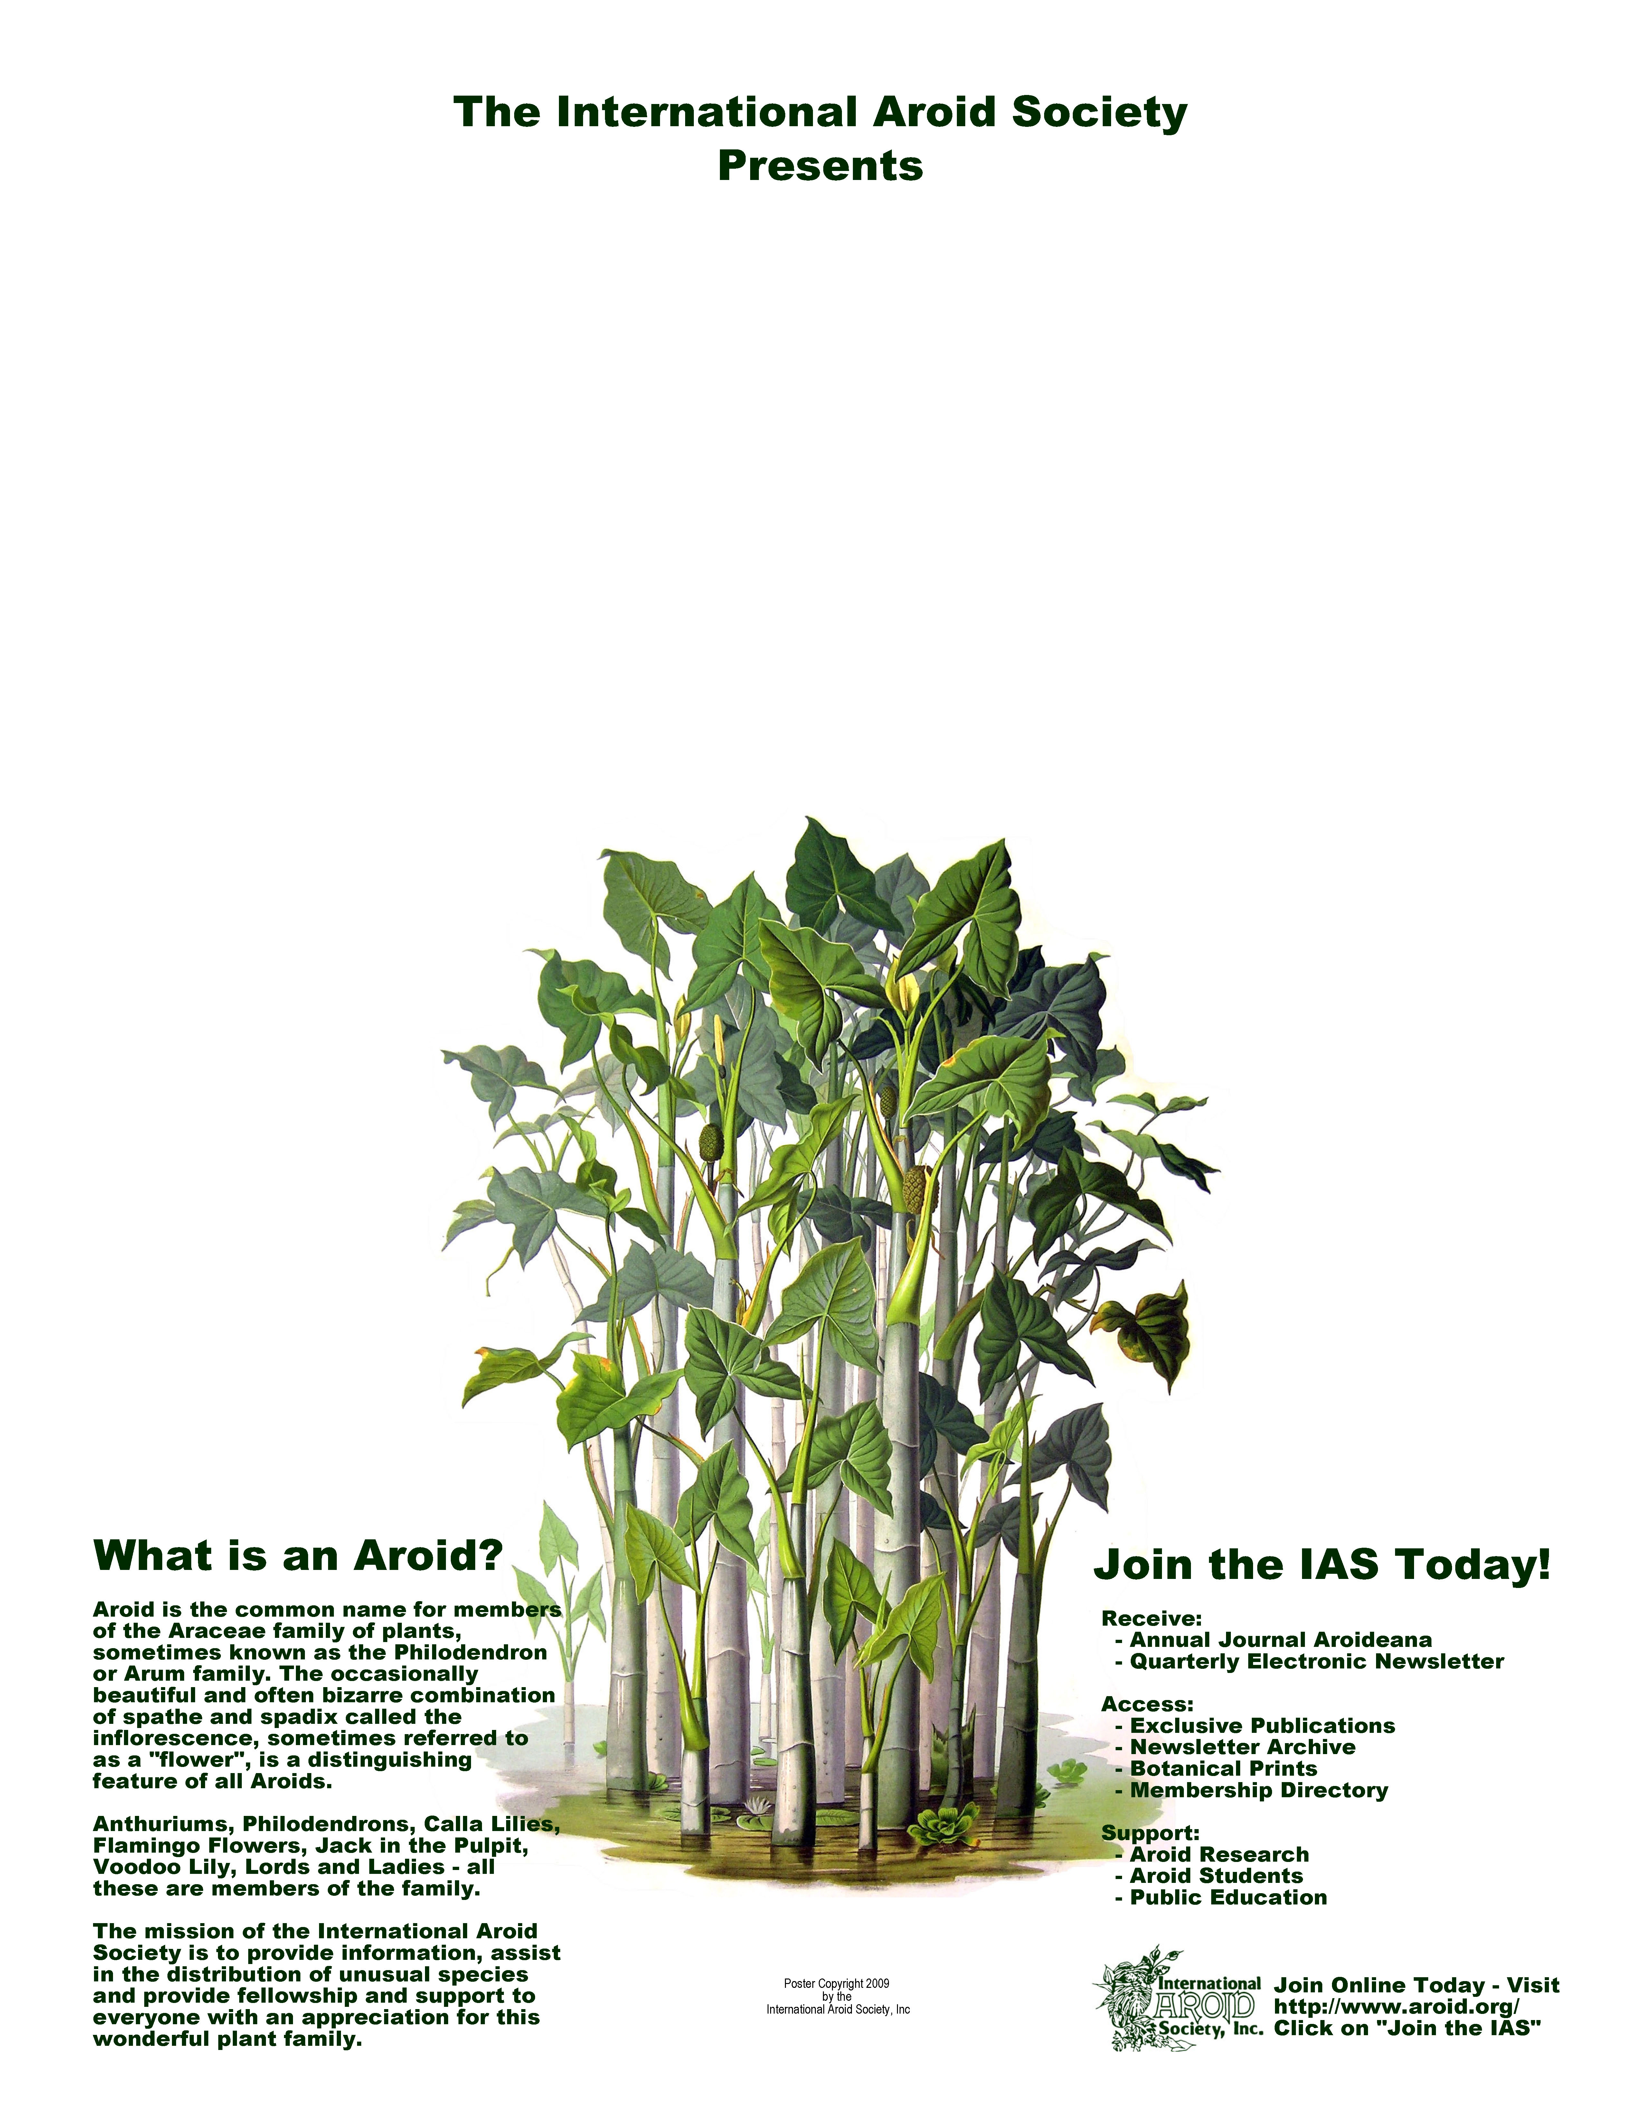
32nd Annual AROID
SHOW AND SALE
September 19th & 20th, 2009
9:30AM – 4:30PM Both Days
Fairchild Tropical Garden*

Miami, Florida, USA
* Show is free with paid garden admission
Visit http://www.aroid.org/show/ for link to a $5 discount

- Rare Plants
- Stunning Displays
- International Vendors
- Saturday Talks

For more information, visit http://www.aroid.org/
Or call Tricia Frank at 305-665-4369

* Show is free with paid garden admission

Awards
♦
Flowers and Foliage
♦
Local
Vendors
♦
For more information, visit http://www.aroid.org/
Or Call Tricia Frank
at 305-665-4369

Rare Plants
♦
Stunning Displays
♦
International Vendors
♦
Saturday
Talks

